December 2, 2021

Name

Second Address

Address

City/State/Zip

Dear Name,

Thank you for your previous gift of ($10,000) which provided resources to thousands of students to improve their educational outcomes last year. With the ongoing COVID-19 pandemic, it is undeniable that **learning interruptions have had a significant emotional and academic impact on Tulsa students over the past 21 months.** The disproportionate impact of these events has made the systemic inequities that exist right here in Tulsa more apparent than ever.

Our students are facing the challenge of closing gaps in learning from the impact of the pandemic these past few years. The opportunity gap has only widened further for Tulsa Public School students compared to their peers in suburban districts. Meeting the scale and intensity of the need today in Tulsa requires different approaches and additional capacity to keep students connected to school and to support resilience in the face of consequential challenges.

Toward this end, City Year Tulsa is focused on two objectives: supporting resiliency and engagement to meet the basic needs of students and families and accelerating learning and supporting recovery from instructional loss. To respond to this need and deepen our impact City Year invested in our programs increasing expenses by 29%. This includes a higher living stipend for AmeriCorps members, new school based staff positions, additional data and analytics capacity, and piloting an Early Warning Indicator program in three of our partner schools.

Over half of this year’s increase has been covered through additional public funding, but **we need additional resources** to respond to our students needs, and lessen the long term repercussions of the pandemic.

**Would you donate to ensure students have the supports they need this school year?** Together, when we invest in the development of children and young adults, especially those who face obstacles to their growth and learning and require extra support, we can ensure that the talents and contributions of all young people are available to our community in the future.

We as a community have a moral imperative to respond to our students’ immediate needs in the wake of this pandemic. With your donation, you can support AmeriCorps members, like Linda, who use their knowledge in math as a resource to help their students, like Mikeal, relearn lessons and catch up on the assignments in class.

Mikeal has a powerful work ethic and positive attitude, but last year, he was unable to keep up virtually and was not engaging in his work. Once they were together in person, Linda was able to work with Mikeal to engage in his class work and reach his potential. His class grade increased from a 7% to an A this fall semester!

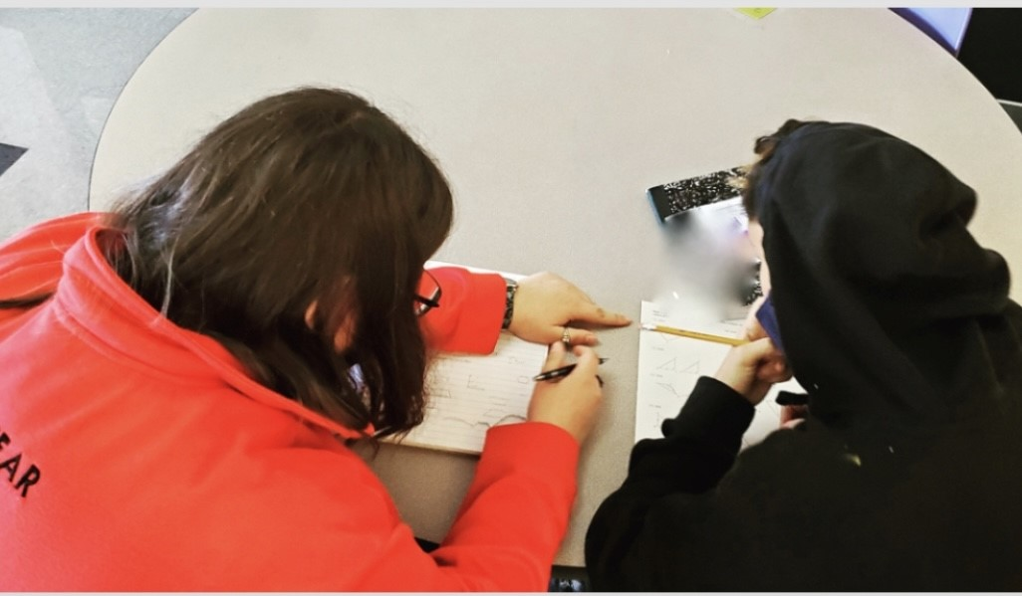*“This was all because we had taken the time to work together and Mikeal was ready to learn. He’s a great student and needed the resource of an adult he trusts at that moment and that gave him the time to understand the work, and I’m so glad I could be that adult.”*

*~Linda*

Mikeal is one of many students who have been supported and impacted by the resources City Year can bring but we need your help to deepen this work. I invite you to donate today and help create educational equity for all in Tulsa. **Would you increase your donation this year so that Mikeal and all our students have the resources they deserve?**

If you have any questions, please contact me at pdavis1@cityyear.org or on my cell at 918.809.1718. On behalf of City Year Tulsa, our school partners, and the students we serve, thank you for your continued support.

Gratefully,

Paul G. Davis   
Executive Director